**Fletcher Induction Requirements & Conditions:**

* **All workers must not turn up for an induction, if they are not well,** have been at a location of interest and are identified as a Covid19 close contact, casual contact plus or casual contact and are awaiting a covid test result, have been instructed by Healthline to stay at home & isolate for a required time period and until a negative test is confirmed.
* **All Workers must bring along their own and wear a face mask for the induction and when arriving at the site location.**
* **Currently under Alert Level 3, please only book in workers that are essential/urgent and approved by FCC supervisor** for current or upcoming essential works, that are requested by Fletchers, to be done within the next 2-week period. Inductions will be kept to minimum, where possible under the current Covid 19 Alert Levels
* **If you are a 2nd or 3rd Tier subcontractor you must provide the company name of the 1st Tier Subcontractor company that has engaged you, when booking your workers induction along with the Work Pack area your workers will be working (i.e. Work pack 1 & 2, 3, 4 & 5 - Hotel).**
* **Please restrict bookings of your workers to a limit of 5 per company per session, to provide spaces to other companies that need to utilise this. If there is a need for greater than 5 workers, please obtain authorisation from EHS team, in advance of booking.**
* All workers are advised to bring along their own pens to use at the induction
* **All workers must physical distance (1m minimum at work site & during induction and 2m while in public spaces/ outside areas or Smoko/lunch areas).**
* **All workers must scan in with their phones using the Site Office Covid Tracer app**, upon entry to the building. The covid app will also be displayed at entrance and available in the induction room to use.
* **Workers must understand and be proficient in English to complete induction.** In the event that a worker cannot speak or understand English, the **company employing them are required to book in a translator with worker**, so they can translate the message to their workers. If this is not provided by the company, the worker will be turned away from the induction. This will be at the inductor’s discretion.
* **Workers are to bring with them to the induction their current Site safe/construct safe card and provide evidence upon request to inductor on arrival.**
* **Workers must be prepared to accept & undergo a Rapid Antigen Covid Test (confirmed Negative) on arrival at the induction.** This is something that we will be introducing in the next few weeks as a current trial. Workers are advised to still get covid 19 PCR tests carried out weekly (on a 5-day basis) and confirm a negative result to their employer. Workers may be asked at the induction, to provide or furnish proof of a negative Covid19 test result (within 5 days). This will be at the inductor’s discretion.
* **Employers and supervisors are to encourage their workers on site to attend weekly (5day) covid 19 surveillance testing**.Fletcher’s offer this testing on site generally on Wednesdays, at the times and allocated areas for each work pack (Refer daily pre-starts for information on dates and time for this).
* **Workers are advised to get vaccinated** and be open to disclosing this information to their employer and for purpose of inductions (on a as required/needed basis). Employers to promote this and encourage this for all their employers.
* **Workers are to turn up 15-30 mins before the induction**, ready to start at 8am. If they do not turn up on time for the induction, are late, end up waiting outside, have issues with getting parking or held up by traffic, they will be turned away and the employer will have to arrange an alternative next available induction for them via our induction website booking page.
* **Address for Induction:** Fletcher new Site Office, Ground Floor, 210 Federal St, Auckland CBD. Please wait outside the entrance of building, an inductor will come and get you when they are ready.  Remember to social distance and wear masks.
* There is no parking on site, so workers will be required to organise their own parking in the CBD for the induction. The induction will take approximately 2 hours.
* **Please ensure that your workers turn up to the induction ready and equipped with the necessary mandatory PPE/ RPE needed to start work on site.**
* By booking in your workers above you have accepted the above Fletcher Induction requirements & conditions.

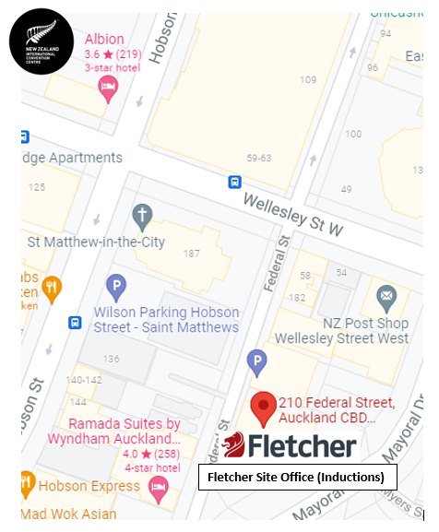**Fletcher Site Office Location Map**